**Naive Bayes Classifier**

Naive Bayes is a powerful and simple probabilistic classifier based on Bayes' Theorem. It's widely used in various applications due to its effectiveness, speed, and ease of implementation.

**Fundamental Probability Concepts**

1. **Probability:** A measure of the likelihood of an event occurring. It ranges from 0 (impossible event) to 1 (certain event).
2. **Sample Space (S):** The set of all possible outcomes of an experiment.
3. **Event (A, B):** A subset of the sample space.
4. **Intersection (A ∩ B):** The event where *both* events A and B occur.
5. **Conditional Probability P(A|B):** The probability of event A occurring *given that* event B has already occurred.

**Independent vs. Dependent Events**

1. **Independent Events:** Two events A and B are independent if the occurrence of one event does *not* affect the probability of the other event occurring.
   * **Mathematical Definition:** A and B are independent if and only if: P(A∩B)=P(A)×P(B)
   * **Conditional Probability Relationship:** If A and B are independent:

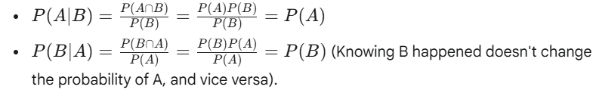

* + **Example:** Tossing a fair coin twice. The outcome of the first toss (Heads or Tails) does not influence the outcome of the second toss. P(Head on 2nd toss∣Head on 1st toss)=P(Head on 2nd toss)=0.5.

1. **Dependent Events:** Two events A and B are dependent if the occurrence of one event *does* affect the probability of the other event occurring.
   * **Mathematical Property:** P(A∩B)=P(A)×P(B)
   * **Conditional Probability Relationship:** The basic definition P(A∣B)=P(B)P(A∩B)​ holds. Knowing B occurred changes the probability of A.
   * **Example:** Drawing two cards from a standard deck *without* replacement. Let A be "drawing a King first" and B be "drawing a King second".
     + P(A)=4/52.
     + If event A occurs (a King is drawn first), then there are only 51 cards left, and only 3 Kings. So, P(B∣A)=3/51.
     + The probability of B depends on whether A happened.
   * **Calculating Joint Probability for Dependent Events:** From the conditional probability formula, we get: P(A∩B)=P(A∣B)×P(B)=P(B∣A)×P(A)
   * 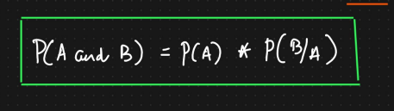

## **Bayes' Theorem**

Bayes' Theorem provides a way to update the probability of a hypothesis based on new evidence. It relates the conditional probability of two events.

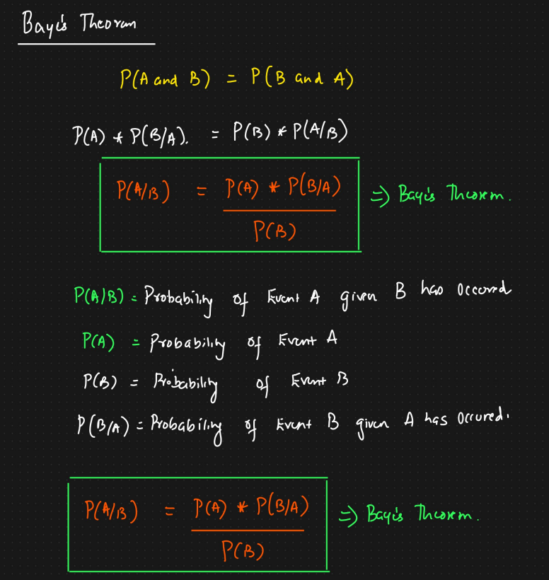

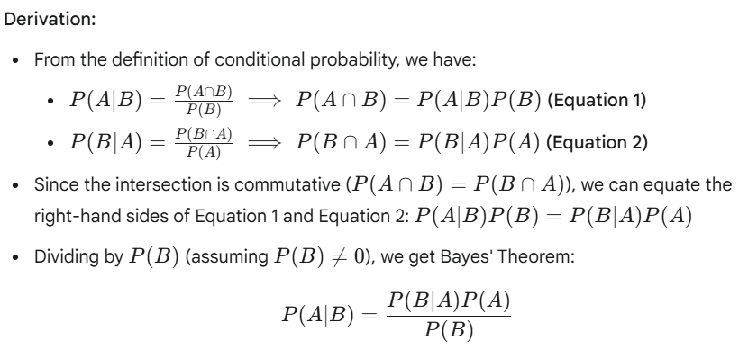

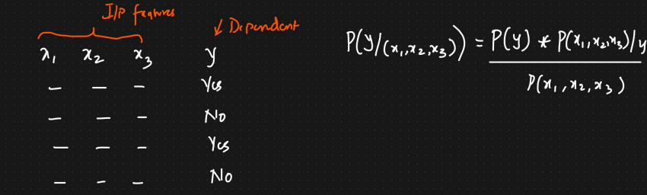

## **Naive Bayes Algorithm**

**1. Introduction:**

* **What it is:** Naive Bayes is a simple yet effective and commonly used **probabilistic classifier** based on **Bayes' Theorem**.
* **Core Idea:** It calculates the probability of a data point belonging to each class and assigns the class with the highest probability.
* **"Naive" Aspect:** It makes a strong ("naive") assumption about the **independence of features**.

**2. Bayes' Theorem:**

* **Goal:** Given a set of features X=(X1​,X2​,...,Xn​), we want to predict the class label C (from a set of possible classes Ck​). We aim to find the class Ck​ that is most probable given the observed features. In other words, we want to maximize the posterior probability P(Ck​∣X1​,...,Xn​).
* **Applying Bayes' Theorem:**

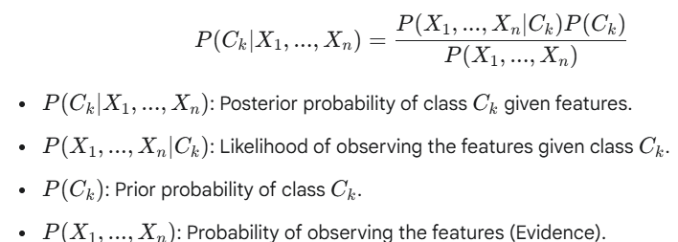

**3. The "Naive" Independence Assumption:**

* **Assumption:** Naive Bayes assumes that all features X = (x1, x2, ..., xn) are **conditionally independent** given the class C.
* **Meaning:** The presence or value of one feature does not affect the presence or value of another feature, given the class.
* **Mathematical Simplification:** This assumption dramatically simplifies the likelihood calculation: P(X | C) = P(x1, x2, ..., xn | C) = P(x1 | C) * P(x2 | C) * ... * P(xn | C)
* **Reality Check:** This independence assumption rarely holds true in real-world data. However, the algorithm often performs surprisingly well even when the assumption is violated.

**4. How Naive Bayes Classification Works:**

* **Goal:** For a new data point with features X, find the class C that maximizes the posterior probability P(C | X).
* **Calculation:** Using Bayes' theorem and the naive assumption: P(C | X) ∝ P(C) * P(x1 | C) * P(x2 | C) * ... * P(xn | C)
  + We calculate this value for *every* class.
  + P(X) (the denominator) is constant for all classes for a given data point, so it can be ignored when just comparing the posterior probabilities.
* **Prediction:** The class C that yields the highest value from the calculation above is assigned as the predicted class for the data point X.
* **Training:** The training phase involves calculating the prior probabilities P(C) for each class and the likelihood probabilities P(xi | C) for each feature xi given each class C, usually based on frequencies in the training data.

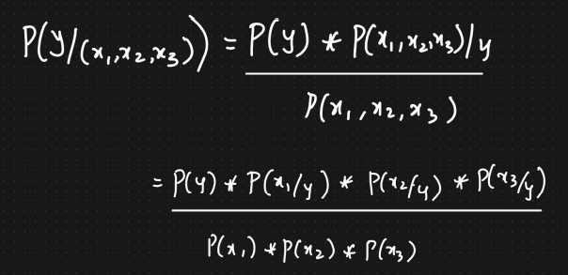

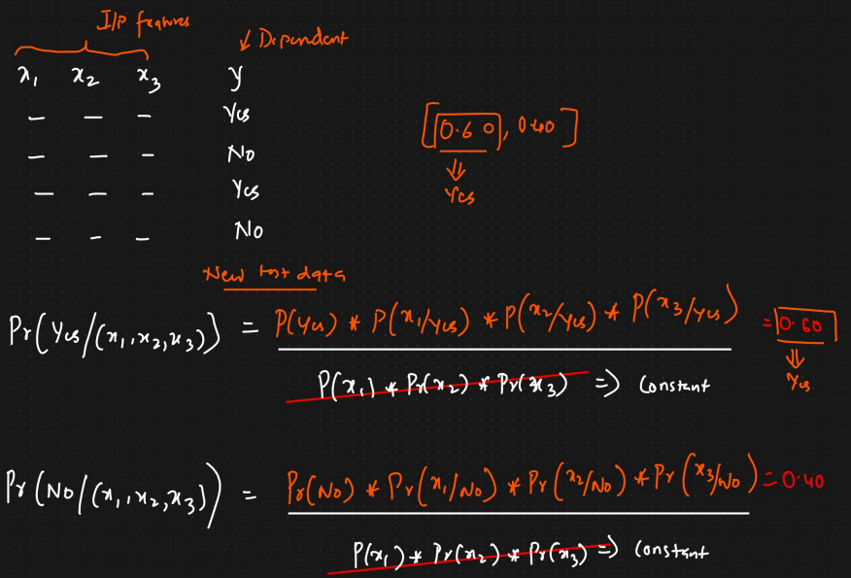

**Golf Dataset Example**

Let's consider a dataset for predicting whether to play golf based on weather conditions:

| **Outlook** | **Temperature** | **Humidity** | **Windy** | **Play Golf** |
| --- | --- | --- | --- | --- |
| Rainy | Hot | High | False | No |
| Rainy | Hot | High | True | No |
| Overcast | Hot | High | False | Yes |
| Sunny | Mild | High | False | Yes |
| Sunny | Cool | Normal | False | Yes |
| Sunny | Cool | Normal | True | No |
| Overcast | Cool | Normal | True | Yes |
| Rainy | Mild | High | False | No |
| Rainy | Cool | Normal | False | Yes |
| Sunny | Mild | Normal | False | Yes |
| Rainy | Mild | Normal | True | Yes |
| Overcast | Mild | High | True | Yes |
| Overcast | Hot | Normal | False | Yes |
| Sunny | Mild | High | True | No |

The dataset is divided into two parts, namely, feature matrix and the response vector.

Assumptions of the **Naive Bayes** algorithm

1. **Feature Independence**:  
    Each feature is assumed to be **independent** of the others given the class label.
2. **Equal Contribution**:  
    All features contribute **equally and independently** to the outcome.
3. **No Feature Interaction**:  
    Assumes **no interaction** between features (i.e., the presence/absence of one feature does not affect another).
4. **Data Distribution**:  
    For continuous data, it assumes **normal (Gaussian) distribution** (in Gaussian Naive Bayes).

Now, with regards to our dataset, we can apply Bayes’ theorem in following way:

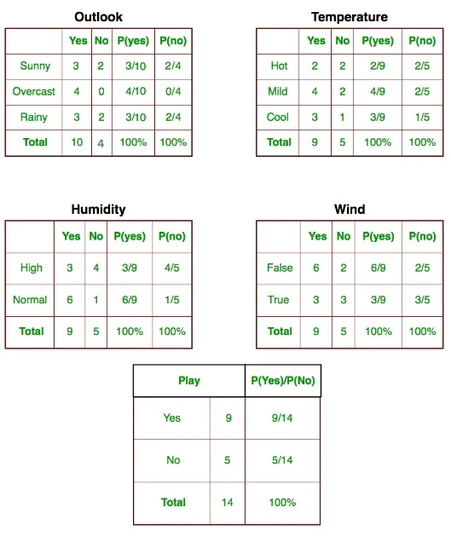

where, y is class variable and X is a dependent feature vector (of size n) where:



Just to clear, an example of a feature vector and corresponding class variable can be: (refer 1st row of dataset)

X = (Rainy, Hot, High, False)

y = No

So basically, P(y∣X)here means, the probability of “Not playing golf” given that the weather conditions are “Rainy outlook”, “Temperature is hot”, “high humidity” and “no wind”.

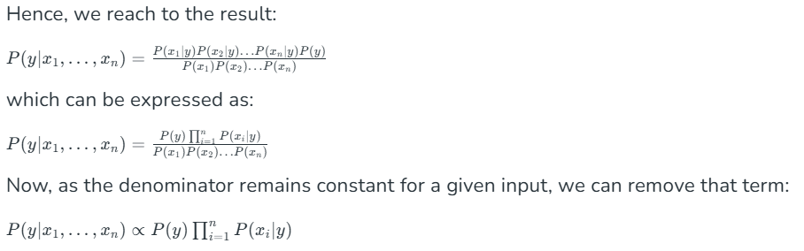

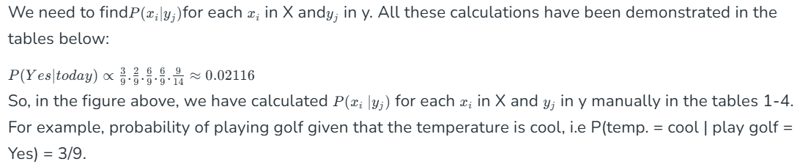

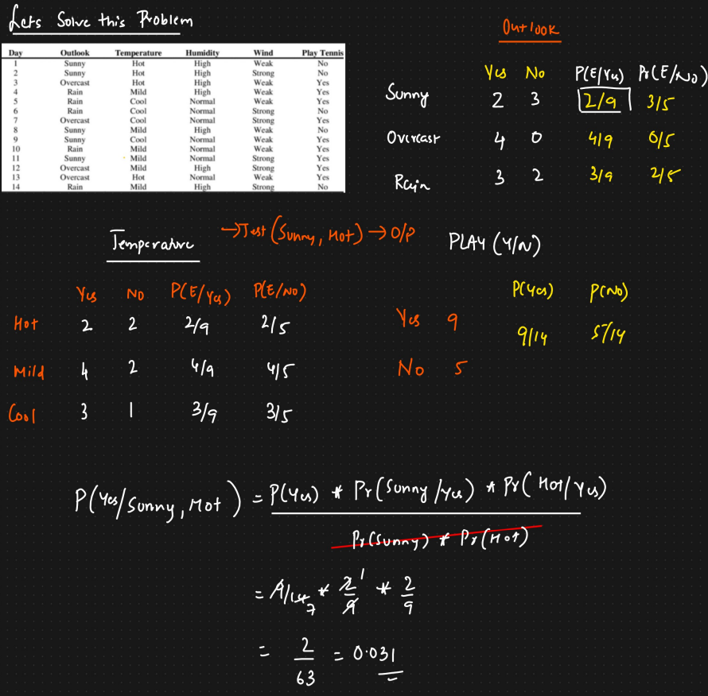

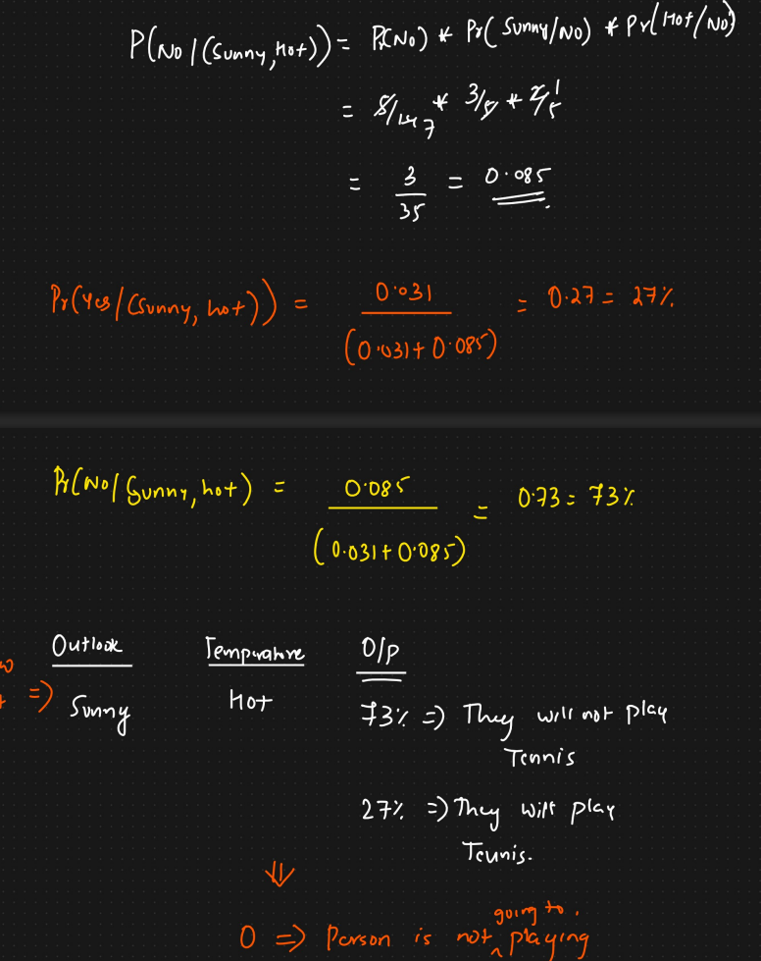

**5. Types of Naive Bayes Classifiers:**

The choice depends on the nature of the features:

* **Gaussian Naive Bayes:**
  + Assumes features follow a **Gaussian (normal) distribution**.
  + Used for **continuous** features.
  + Calculates the mean and standard deviation of each feature for each class during training.
  + Use case: Sensor measurements, physical properties (density, hardness, etc.)
* **Multinomial Naive Bayes:**
  + Typically used for **discrete counts**.
  + Common in **text classification** (e.g., word counts in documents).
  + Often uses **Laplace (or Additive) smoothing** to handle cases where a feature count is zero in the training data for a given class.
  + Use case: Text classification, mineral composition percentages, frequency-based features
* **Bernoulli Naive Bayes:**
  + Used for **binary/boolean features** (feature is present or absent).
  + Also common in text classification (e.g., presence/absence of a word).
  + Use case: Presence/absence of minerals, binary sensor readings, pass/fail tests

**6. Advantages:**

* **Simple and Fast:** Easy to implement and computationally efficient for both training and prediction.
* **Requires Less Training Data:** Can perform well even with relatively small datasets.
* **Scales Well:** Handles high-dimensional data (many features) effectively, like in text classification.
* **Good Performance:** Often works surprisingly well even if the independence assumption isn't fully met.
* Handles different feature types through variants (Gaussian, Multinomial, Bernoulli).

**7. Disadvantages:**

* **Unrealistic Independence Assumption:** The core assumption is often violated in reality, which is its main theoretical limitation (though often not a practical one).
* **Zero-Frequency Problem:** If a specific feature value doesn't appear with a specific class in the training data, its conditional probability becomes zero, potentially wiping out the entire posterior probability. (Mitigated by smoothing techniques like Laplace smoothing).
* **Potentially Poor Probability Estimates:** While classification ranking might be good, the actual estimated probabilities can be inaccurate if the independence assumption is strongly violated.
* **Sensitivity to Feature Distribution:** Performance depends on features matching the distribution assumed by the chosen variant (e.g., Gaussian for Gaussian NB).

**8. Common Applications:**

* Text Classification (Spam Filtering, Sentiment Analysis, Topic Categorization)
* Medical Diagnosis
* Recommendation Systems
* Fraud Detection